GUATEMALA: Joint statement in support of Guatemalan lawyer Claudia González, condemning her detention and calling for her immediate release
5 September 2023
The International Observatory for Lawyers in Danger (OIAD), Lawyers for Lawyers, and the undersigned organisations condemn the arrest of human rights lawyer Claudia González Orellana, which took place in Guatemala City on 28 August 2023.
Claudia González Orellana was a representative for the International Commission Against Impunity in Guatemala (CICIG), committed to the fight against impunity of serious human rights violations and corruption. Because of this work, she has been subjected to harassment through social networks and verbal threats that indicate that she herself may be criminally prosecuted. She has faced multiple cases of judicial harassment, the latest of which was a bogus case in which she was accused of forging the signature of the country's top anti-corruption prosecutor.
Despite this situation, Claudia is currently using her more than 20 years of experience to continue working in the defence of human rights in Guatemala, as she is legal counsel for nine former colleagues from the CICIG and other former prosecutors. In recognition of her work and dedication, she was awarded the Lawyers for Lawyers award 2023.
On the morning of 28 August 2023, lawyer Claudia González was arrested, charged with the crime of abuse of authority. The arrest took place following a search of her home ordered by the Public Prosecutor's Office, as part of the alleged investigation proceedings against her. However, prior to her arrest, Claudia repeatedly went to the prosecutor’s office to request information about possible proceedings against her, without result. It came to our attention that other former CICIG and FECI (Special Prosecutor's Office against Impunity in Guatemala) workers faced arrest warrants on this date as well. Claudia’s arrest warrant was signed by Jimi Rodolfo Bremer Ramírez, tenth pluripersonal judge of first criminal instance. Reportedly, Claudia is currently held in solitary confinement during her pre-trial detention. On 6 September the first hearing in her case will take place despite the requirement under Guatemalan law that it takes place within 24 hours of the detention.
According to Claudia González, this arrest is motivated solely by her work as defence lawyer of Juan Francisco Sandoval, Virginia Laparra, Paola Escobar, Carlos Vides, Eva Siomara Sosa and others, all of them former members of CICIG or FECI (. The criminal process against Claudia represents a clear attempt of retaliation for her work at CICIG and her attempt to seek justice for those being unfairly criminalized in her profession. Claudia’s arrest leaves her clients unprotected in their legal processes.
Lawyers play a vital role in upholding the rule of law and the protection of human rights and their work is indispensable for public confidence in the administration of justice and to ensure access to justice for all.
The undersigned organizations would like to draw your attention to the United Nations Basic Principles on the Role of Lawyers, particularly Article 16, which states:
16. Governments shall ensure that lawyers (a) are able to perform all of their professional functions without intimidation, hindrance, harassment or improper interference; (…) and (c) shall not suffer, or be threatened with, prosecution or administrative, economic or other sanctions for any action taken in accordance with recognized professional duties, standards and ethics.
The undersigned organisations express their concern about the lack of judicial independence in the actions of the Public Prosecutor's Office and the magistrate in charge of the case against lawyer Claudia Gonzalez. In particular, we are concerned about the lack of grounds to carry out the search of her home and for her detention.
The undersigned organisations are concerned about the high risks faced by human rights lawyers in Guatemala. This deprivation of liberty, added to the previous threats and harassment derived from their work, results in a staggered sequence of incidents, generating a violation of their physical, emotional and psychological integrity.
For the above reasons, the undersigned organisations urge the Guatemalan authorities to:
1. Immediately and unconditionally release lawyer Claudia González.
2. Take all necessary measures to guarantee the rights to due process, legal defence and access to justice in the case of Claudia González.
3. Guarantee that all lawyers in Guatemala are able to carry out their legitimate professional activities without fear of reprisals and free of all undue restrictions including judicial harassment arbitrary arrest, deprivation of liberty or other arbitrary sanctions.

The following organisations sign this statement:
 | 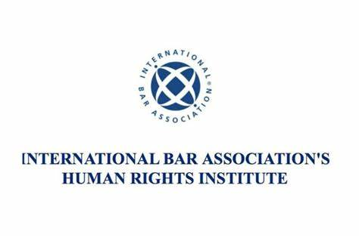 |  | 
Lawyers Rights Watch Canada | International Bar Association’s Human Rights Institute (IBAHRI) |  | The Law Society of England and Wales
 | 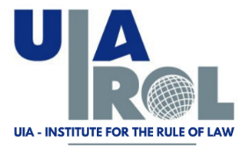 |  | 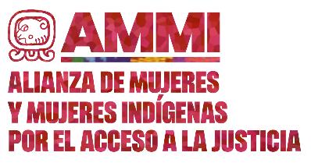
Council of Bars and Law Societies of Europe (CCBE) | Institute for the Rule of Law of the International Association of Lawyers (UIA-IROL) |  | Alianza de Mujeres y Mujeres Indígenas por el Acceso a la Justicia
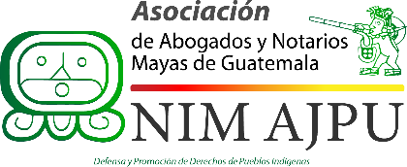 | 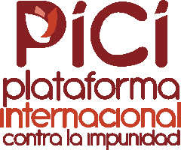 |  | 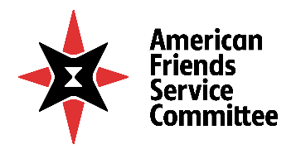
Asociación de Abogados y Notarios Mayas de Guatemala -NIM AJPU- | Plataforma Internacional contra la Impunidad |  | American Friends Service Committee – LAC
 | 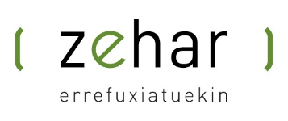 |  | 
Sector Interreligioso Centinelas por la Dignificación del Estado | Zehar-Errefuxiatuekin |  | Latin America Working Group (LAWG)
 |  | 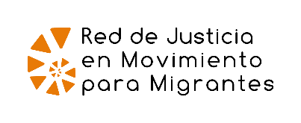
Frontline Defenders |  | Red de Justicia en Movimiento para Migrantes
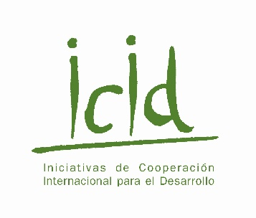 | 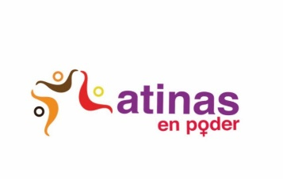 |  | 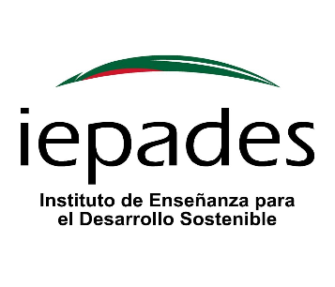
Iniciativas de Cooperación Internacional para el Desarrollo (ICID) | Latinas en poder |  | Instituto de Enseñanza para el Desarrollo Sostenible (IEPADES)
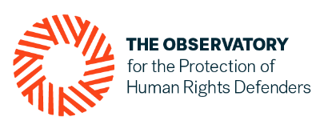
Organización mundial contra la tortura (OMCT), en el marco del Observatorio para la Protección de los Defensores de Derechos Humanos |  | Federación Internacional por los Derechos Humanos (FIDH), en el marco del Observatorio para la Protección de los Defensores de Derechos Humanos
 | 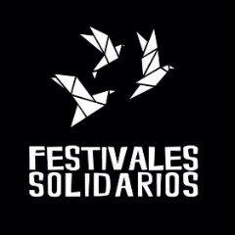 |  | 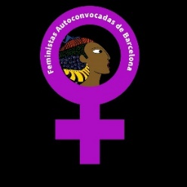
Sembramos futuro | Festivales solidarios |  | Feministas Autoconvocadas de Barcelona
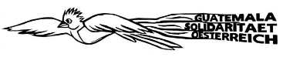 |  |  | 
Solidaridad con Guatemala de Austria | Ecologistas en Acción |  | Lumaltik Herriak
 |  | 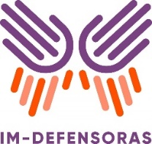
Sector Mujeres |  | Iniciativa Mesoamericana de mujeres defensoras de derechos humanos (IM-Defensoras)

The OIAD is an initiative founded by the French National Bar Council (France), the Paris Bar (France), the Spanish National Bar Council (Spain) and the Italian National Bar Council (Italy) and it represents 49 bar association that support the project. This Observatory was created with the aim of coordinating its work with other entities, networks and mechanisms that operate in the field of protection for lawyers in general and human rights lawyers in particular. One of our areas of work is to make international alerts visible and send communications to national authorities, diplomatic authorities, international organisations and regional and international protection mechanisms urging them to act in favour of the particular case or situation identified.
Lawyers for Lawyers (L4L) is an independent, non-political and not-for-profit lawyers’ organization established in 1986. Our mission is to promote the independent functioning of lawyers and the legal profession across the world in accordance with internationally recognized norms and standards. Our work to support lawyers who are at risk as a result of discharging their professional duties, seeks to protect them from threats, risks and reprisals, strengthens their international recognition and protection in laws, policies and practices, and empower them to fulfil their role as essential agents of the administration of Justice. Lawyers for Lawyers was granted special consultative status with the UN Economic and Social Council in July 2013.
Jimi Rodolfo Bremer Ramírez was mentioned in the United States Report to Congress on Foreign Persons who have Knowingly Engaged in Actions that Undermine Democratic Processes or Institutions, Significant Corruption, or Obstruction of Such Corruption in El Salvador, Guatemala, and Honduras Section 353(b) of the Department of State, Foreign Operations, and Related Programs Appropriations Act, 2021 (Div. FF, P.L. 116-260), accessed via https://www.state.gov/reports/section-353-corrupt-and-undemocratic-actors-report-2023/.

